Clouds: An Opportunity for Scientific Applications?

Ewa Deelman¹, Bruce Berriman², Gideon Juve¹, Yang-Suk Kee³, Miron Livny⁴, Gurmeet Singh¹

¹USC Information Sciences Institute, Marina del Rey, CA
²Processing and Analysis Center & Michelson Science Center, California Institute of Technology, Pasadena, CA
³Oracle US Inc
⁴University of Wisconsin Madison, Madison, WI

Introduction
Science applications today are becoming ever more complex. They are composed of a number of different application components, often written by different individuals and targeting a heterogeneous set of resources. The applications often involve many computational steps that may require custom execution environments. These applications also often process large amounts of data and generate large results. As the complexity of the scientific questions grows so does the complexity of the applications being developed to answer these questions.
Getting a result is only part of the scientific process. There are three other critical components of scientific endeavors: reproducibility, provenance, and knowledge sharing. We describe them in turn in the context of the scientific applications and revisit them towards the end of the chapter, evaluating how Clouds can meet these three challenges.
As the complexity of the applications increases, reproducibility [1, 2], the cornerstone of the scientific method, is becoming ever harder to achieve. Scientists often differentiate between scientific and engineering reproducibility. The former implies that another researcher can follow the same analytical steps, possibly on different data, and reach the same conclusions. Engineering reproducibility implies that one can reproduce the same result (on the same data with the same software) bit-by-bit. Reproducibility is hard to achieve because applications rely on a number of different software and different software versions (some at the system level and some at the application level) and access a number of data that can be distributed in the environment and can change over time (for example raw data may be calibrated in different ways as the understanding of the instrument behavior improves).
Reproducibility is only one of the critical components of the scientific method. As the complexity of the analysis grows, it is becoming very difficult to determine how the data were created. This is especially complex when the analysis consists of a large-scale computation with thousands of tasks accessing hundred of data files. Thus the “capture and generation of provenance information is a critical part of the <…> generated data” [1].
Sharing of knowledge, of how to obtain particular results, of how to go about approaching a particular problem, of how to calibrate the raw data, etc. are fundamental elements of educating new generations of scientists and of accelerating knowledge dissemination. When a new student joins a lab, it is important to quickly bring them up to speed, to teach him or her how to run a complex analysis on data being collected. When sharing results with a colleague, it is important to be able to describe exactly the steps that took place, which parameters were chosen, which software was used, etc. Today sharing is difficult because of the complexity of the software and of how it needs to be used, of what parameters need to set, of what are the acceptable data to use, and of the complexity of the execution environment and its configuration (what systems support given codes, what message passing libraries to use, etc.).
Besides, these over-reaching goals, applications also face computational challenges. Applications need to be able to take advantage of smaller, fully encapsulated components. They need to execute the computations reliably and efficiently while taking advantage of any number and type of resources including a local cluster, a shared cyberinfrastructure [3, 4], or the Cloud [5]. In all these environments there is a tradeoff between cost, availability, reliability, and ease of use and access.
One possible solution to the management of applications in heterogeneous execution environments is to structure the application as a workflow [6, 7] and let the workflow management system manage the execution of the application in different environments. Workflows enable the stitching of different computational tasks together and formalize the order in which the tasks need to execute. In astronomy, scientists are using workflows to generate science-grade mosaics of the sky [8], to examine the structure of galaxies [9] and in general to understand the structure of the universe. In bioinformatics, they are using workflows to understand the underpinnings of complex diseases [10, 11]. In earthquake science, workflows are used to predict the magnitude of earthquakes within a geographic area over a period of time [12]. In physics workflows are used to try to measure gravitational waves [13].
In our work, we have developed the Pegasus Workflow Management System (Pegasus-WMS) [14, 15] to map and executed complex scientific workflows on a number of different resources. In this context, the application is described in terms of logical components and logical data (independent of the actual execution environment) and the dependencies between the components. Since the application description is independent of the execution environment, mappings can be developed that can pick the right type of resources in an number of different execution environments [15], that can optimize workflow execution [16], and that can recover from execution failures [17, 18].

In this chapter we examine the issues of running workflow-based applications on the Cloud focusing on the costs incurred by an application when using the Cloud for computing and/or data storage. With the use of simulations, we evaluate the cost of running an astronomy application Montage [19] on the Cloud such as Amazon EC2/S3 [20].

The opportunity of the Cloud
Clouds have recently appeared as an option for on-demand computing. Originating in the business sector, Clouds can provide computational and storage capacity when needed, which can result in infrastructure savings for a business. For example, when a business invests in a given amount of computational capacity, buying servers, etc., they often need to plan for enough capacity to meet peak demands. This leaves the resources underutilized most of the time. The idea behind the Cloud is that businesses can plan only for a sustained level of capacity while reaching out to the Cloud resources in times of peak demand. When using the Cloud, applications pay only for what they use in terms of computational resources, storage, and data transfer in and out of the Cloud. In the extreme, a business can outsource all of its computing to the Cloud. Clouds are delivered by data centers strategically located in various energy-rich locations in the US and abroad. Because of the advances in network technologies, accessing data and computing across the wide area network is efficient from the point of view of performance. At the same time locating large-computing capabilities close to energy sources such as rivers, etc is efficient from the point of energy usage.
Today Clouds are also emerging in the academic arena, providing a limited number of computational platforms on demand: Nimbus [21], Eucalyptus [22], Cumulus [23], etc. These Science Clouds provide a great opportunity for researchers to test out their ideas and harden codes before investing more significant resources and money into the potentially larger-scale commercial infrastructure. In order to support the needs of a large number of different users with different demands on the software environment, Clouds are primarily built using resource virtualization technologies [24-27] that enable the hosting of a number of different operating systems and associated software and configurations on a single hardware host.
Clouds that provide computational capacities (Amazon EC2 [20], Nimbus [21], Cumulus [23], etc) are often referred as an Infrastructure as a Service (IaaS) because they provide the basic computing capabilities needed to deploy service. Other forms of Clouds include Platform as a Service (PaaS) that provide an entire application development environment and deployment container such as Google App Engine [28]. Finally, Clouds also provide complete services such as photo sharing, instant messaging [29], and many others (termed as Software as a Service (SaaS).
As already mentioned, commercial Clouds were built with business users in mind, however, scientific applications often have different requirements than enterprise customers. In particular, scientific codes often have parallel components and use MPI [30] or shared memory to manage the message-based communication between processors. More coarse-grained parallel applications often rely on a shared file system to pass data between processes. Additionally, as mentioned before, scientific applications are often composed of many inter-dependent tasks and consume and produce large amounts of data (often in the TeraByte range [12, 13, 31]). Today, these applications are running on the national and international cyberinfrastructure such as the Open Science Grid [4], the TeraGrid [3], EGEE [32], and others. However, scientists are interested in exploring the capabilities of the Cloud for their work.
Clouds can provide benefits to today’s science applications. They are similar to the Grid, as they can be configured (with additional work and tools) to look like a remote cluster, presenting interfaces for remote job submission and data stage-in. As such scientists can use their existing grid software and tools to get their work done. Another interesting aspect of the Cloud is that by default it includes resource provisioning as part of the usage mode. Unlike the Grid, where jobs are often executed on a best-effort basis, when running on the Cloud, a user requests a certain amount of resources and has them dedicated for a given duration of time. (An open question in today’s Clouds is how many resources and how fast can anyone request at any given time.) Resource provisioning is particularly useful for workflow-based applications, where overheads of scheduling individual, inter-dependent tasks in isolation (as it is done by Grid clusters) can be very costly. For example, if there are two dependent jobs in the workflow, the second job will not be released to a local resource manager on the cluster until the first job successfully completes. Thus the second job will incur additional queuing time delays. In the provisioned case, as soon as the first job finishes, the second job is released to the local resource manager and since the resource is dedicated, it can be scheduled right away. Thus the overall workflow can be executed much more efficiently.
Virtualization also opens up a greater number of resources to legacy applications. These applications are often very brittle and require a very specific software environment to execute successfully. Today, scientists struggle to make the codes that they rely on for weather prediction, ocean modeling, and many other computations to work on different execution sites. Noone wants to touch the codes that have been designed and validated many years ago in fear of breaking their scientific quality. Clouds and their use of virtualization technologies may make these legacy codes much easier to run. Now, the environment can be customized with a given OS, libraries, software packages, etc. The needed directory structure can be created to anchor the application in its preferred location without interfering with other users of the system. The downside is obviously that the environment needs to be created and this may require more knowledge and effort on the part of the scientist then they are willing or able to spend.
In this chapter, we focus on a particular Cloud, Amazon EC2 [20]. On Amazon, a user requests a certain number of a certain class of machines to host the computations. One also can request storage on Amazon S3 storage system. This is a fairly basic environment in which virtual images need to deployed and configured. Virtual images are critical to making Clouds such as Amazon EC2 work. One needs to build an image with the right operating system, software packages etc. and then store them in S3 for deployment. The images can also contain the basic grid tools such as Condor [33], Globus [34], higher-level software tools such as workflow management systems (for example Pegasus-WMS [14]), application codes, and even application data (although this is not always practical for data-intensive science applications). Science applications often deal with large amounts of data. Although EC2-like Clouds provide 100-300GB of local storage that is often not enough, especially since it also needs to hosts the OS and all other software. Amazon S3 can provide additional long-term storage with simple put/get/delete operations. The drawback to S3 for current grid applications is that it does not provide any grid-like data access such as GridFTP [35]. Once an image is built it can be easily deployed at any number of locations. Since the environment is dynamic and network IPs are not known beforehand, dynamic configuration of the environment is key. In the next section we describe a technology that can manage multiple virtual machines and configure them as a Personal Cluster.

Managing applications on the Cloud
In recent years, a number of technologies have emerged to manage the execution of applications on the Cloud. Among them are Nimbus [21] with its virtual cluster capabilities and Eucalyptus with its EC-2 like interfaces [22]. Here, we describe a system that allows a user to build a Personal Cluster that can bridge the Grid and Cloud domains and provide a single point of entry for user jobs.

Personal cluster
Best-effort batch queuing has been the most popular resource management paradigm used for high-performance scientific computing. Most clusters in production today employ a variety of batch systems such as PBS (Portable Batch System) [36], Condor [37], LSF (Load Sharing Facility) [38], and so on for efficient resource management and QoS (Quality of Service). Their major goal is to achieve high throughput across a system and maximize the system utilization. In the meantime, we are facing a new computing paradigm based on virtualization technologies such as virtual cluster and compute Clouds for parallel and distributed computing. This new paradigm provisions resources on demand and enables easy and efficient resource management for application developers. However, scientists commonly have difficulty in developing and running their applications, fully exploiting the potentials of a variety of paradigms because the new technologies introduce additional complexity to the application developers and users. In this sense, configuring a common execution environment automatically on the behalf of users regardless of local computing environments can lessen the burden of application development significantly. The Personal Cluster was proposed to pursue this goal.
The Personal Cluster [39] is a collection of computing resources controlled by a private resource manager, instantiated on demand from a resource pool in a single administrative domain such as batch resources and compute clouds. The Personal Cluster deploys a user-level resource manager to a partition of resources at runtime, which resides on the resources for a specified time period on the behalf of the user and provides a uniform computing environment, taking the place of local resource managers. In consequence, the Personal Cluster gives an illusion to the user that the instant cluster is dedicated to the user during the application’s lifetime and that she/he has a homogeneous computing environment regardless of local resource management paradigms. Figure 1 illustrates the concept of Personal Cluster. Regardless of whether resources are managed by a batch scheduler or a Cloud infrastructure, the Personal Cluster instantiates a private cluster only for the user, configured with a dedicated batch queue (i.e. PBS) and a web services (i.e., WS-GRAM [40]) on-the-fly. Once a Personal Cluster instance is up and running, the user can run his/her application by submitting jobs into the private queue directly.

Figure 1. The Concept of the Personal Cluster.

Scientists can benefit from the Personal Cluster in a variety of aspects. First, the Personal Cluster provides a uniform job/resource management environment over heterogeneous resources regardless of system-level resource management paradigms. For instance, to execute a job on batch resources, the users have to write a job submission script. If users want to run their applications on heterogeneous resources such as TeraGrid [41], they have to write multiple job descriptions for each resource. Similarly, users need to run individual jobs on each processor using the secure shell tools such as ssh and scp for compute Clouds. The Personal Cluster lessens this burden for the user by providing a uniform runtime environment regardless of local resource management software. That is, the commodity batch scheduler installed for the allocated resources makes the execution environment homogeneous and consistent.
Second, the Personal Cluster can provide QoS of resources when using space-sharing batch resources. The common interest of scientists is to achieve the best performance of their applications in a cost-effective way. However, space-sharing batch systems are unlikely to optimize the turnaround time of a single application especially consisting of multiple tasks against the fair sharing of resources between jobs. For the best-effort resource management, the tasks submitted for an application have to compete for resources with other applications. In consequence, the execution time of an application that consists of multiple jobs (e.g., workflows, parameter studies) is unpredictable because other applications can interrupt the jobs in the progress of application. If an application is interrupted by a long-running job, the overall turnaround time of the application can be delayed significantly. In order to prevent the performance degradation due to such interruptions, the user can cluster the tasks together and submit a single script that runs the actual tasks when the script is executed. However, this clustering technique cannot be benefited by the common capabilities for efficient scheduling such as backfilling provided by resource management systems. By contrast, the Personal Cluster can have an exclusive access to the resource partition during the application’s lifetime once local resource managers allocate resource partitions. In addition, the private batch scheduler of Personal Cluster can optimize the execution of application tasks.
Third, the Personal Cluster enables a cost-effective resource allocation. Since the Personal Cluster acquires resources via default local resource allocation strategy and releases them immediately at termination, it requires neither any modifications of local schedulers nor extra cost for reservation. In the sense that a resource partition is dedicated for the application, a user-level advance reservation is a promising solution to secure performance [42]. However, the user-level advance reservation is still neither popular nor cheap in general because it adversely affects the fairness and the efficient resource utilization. In addition, user-level advance reservation can be cost-ineffective because the users have to pay for the entire reservation period regardless of whether they use the resources or not. Resource providers may charge more on the users for reservation since reservation can be adverse to efficient resource utilization of the entire system and the fairness between jobs. By contrast, the Personal Cluster can have the same benefits without the resources having any special scheduler like advance reservation. The Personal Cluster does not cause any surcharge for reservation since the resources are allocated in a best-effort manner. Moreover, they can terminate at any time without any penalty because the allocated resources will be returned immediately at termination.
Finally, the Personal Cluster leverages commodity tools. A resource manager plays not only as a placeholder for the allocated resources but also as a gateway taking care of resource-specific accesses as well as task launching and scheduling. It is redundant and unnecessary to implement a new job/resource manager for this purpose. As an alternative, the Personal Cluster employs commodity tools for this purpose. The commodity tools provide a vehicle for efficient resource management and make the application development simple.
The current implementation of Personal Cluster is based on the WS-based Globus Toolkit [43] and a PBS [36] installation. The Personal Cluster uses the similar mechanism to Condor glidein [44]. Once a system-level resource manager allocates a partition of resources, a user-level PBS scheduled on the resources holds the resources for a user-specified time and a user-level WS-GRAM (configured at runtime for the partition) accepts jobs from the user and relays them to the user-level PBS. As a result, users can bypass the system-level resource manager and benefit from the low scheduling overhead with the private scheduler.

Personal Cluster on batch resources
A barrier to instantiating a Personal Cluster on batch-controlled resources is the network configuration of the cluster such as firewall, access control, etc. The Personal Cluster assumes a relatively conservative configuration where a remote user can access the clusters via public gateway machines while the individual nodes behind batch systems are private and the accesses to the allocated resources are allowed only during the time period of resource allocation. Then, a batch scheduler allocates a partition of resources and launches the placeholders for Personal Cluster on the allocated resources via remote launching tools such as rsh, ssh, pbsdsh, mpiexec, etc, depending on the local administrative preference. Thus, the security of Personal Cluster relies on that provided by local systems.

Figure 2. The Personal Cluster on Batch Resources.

A client component called PC factory instantiates Personal Clusters on the behalf of user, submitting resource requests to remote batch schedulers, monitoring the status of resource allocation process, and setting up default software components. In essence, the actual job the factory submits sets up a private, temporary version of PBS on a per application basis. This user-level PBS installation has access to the resources and accepts the application jobs from the user. As a foundation software, the Personal Cluster uses the most recent open source Torque package [45] and made several source level modifications to enable a user-level execution. In theory, this user-level PBS can be replaced with other resource managers running at the user-level.
Figure 2 illustrates how to configure a personal cluster using the user-level PBS and WS-GRAM service when the resources are under the control of a batch system and Globus Toolkits based on Web Services (i.e., GT4) provide the access mechanisms. A user-level GRAM server and a user-level PBS are preinstalled on the remote cluster and the user-level GRAM-PBS adaptor is configured to communicate with the user-level PBS. The PC factory first launches a kick-start script to identify the allocated resources and then invokes a bootstrap script for configuring the PBS daemons on each node. The kick-start script assigns an ID for each node, not each processor, and identifies the number of processors allocated for each node. For batch resources, a system-level batch scheduler will launch this kick-start script on the resources via a system-level GRAM adaptor (e.g., GRAM-PBS, GRAM-LSF). If a local resource manager does not have any mechanism to launch the kick start script on the individual resources, the PC factory launches it one by one using ssh. Once the kick-start script has started successfully, the system-level batch scheduler retreats and the PC factory regains the control of the allocated resources. At last, the bootstrap script configures the user-level PBS for the resources on a per-node basis. The node with ID 0 hosts a PBS server (i.e., pbs_server) and a PBS scheduler (i.e., pbs_sched) while the others host PBS workers (i.e., pbs_mom). In the meantime, the bootstrap script creates the default directories for log, configuration files, and so on; generates a file for the communication with the personal GRAM-PBS adaptor (i.e., globus-pbs.conf), configures the queue management options; and starts the daemon executables, based on its role. Finally, the PC factory starts a user-level WS-GRAM server via the system-level GRAM-FORK adaptor on a gateway node of the resources.
Once the user-level PBS and GRAM are in production, the user can bypass the system-level scheduler and utilize the resources as if a dedicated cluster is available. Now a personal cluster is ready and the user can submit application jobs via the private, temporary WS-GRAM service using the standard WS-GRAM schema or directly submit them to the private PBS, leveraging a variety of PBS features for managing the allocation of jobs to resources.

Personal Cluster on the Cloud
A personal cluster is instantiated on compute Clouds through the similar process for batch resources. However, since the virtual processors from the Cloud are instantiated dynamically, the Personal Cluster should deal with the issues due to the system information determined at runtime such as hostname and IP.
The PC factory first constructs a physical cluster with the default system and network configurations. The PC factory boots a set of virtual machines by picking a preconfigured image from the virtual machine image repository. When all virtual machines are successfully up and running, the factory weaves them with NFS (Network File System). Specifically, only the user working directory is shared among the participated virtual processors. Then, the factory registers all virtual processors as known host and share the public key and private key of the user for secure shell so the user can access to every virtual processor using the ssh without password. It also generates an MPI (Message Passing Interface) machine file for the participating processors. Finally, the factory disables the remote access to all processors except one that plays as a gateway node. The user can access the Personal Cluster instance through the user-level PBS and WS-GRAM setup on the gateway node.
One critical issue is to have a host certificate for the WS-GRAM service. A node hosting the GRAM service needs a host certificate based on host name or IP for the user to be able to authenticate the host. However, the hostname and IP of virtual processor is dynamically determined at runtime. As such, we cannot obtain a host certificate for a virtual processor permanently, which implies that the system-level GRAM service cannot be setup for clouds dynamically. Instead, we use the self authentication method so that the factory starts the WS-GRAM service using the user’s certificate without setting up host certificate. A user certificate can be imported into the virtual processors by using the myproxy service. The secure shell access with password and Globus self-authentication method enable only the user to access and use the Personal Cluster instance. Once this basic configuration is completed, the factory repeats the same process for batch resources and setup the user-level PBS and WS-GRAM service

Montage application
So far, we focused on the technology-side of the equation. In this section, we examine a single application, which is a very important and popular astronomy application. We use the application as a basis of evaluating the cost/performance tradeoffs of running applications on the Cloud. It also allows us to compare the cost of the Cloud for generating science products as compared to the cost of using your own compute infrastructure.

What Is Montage and Why Is It Useful?
Montage [8] is a toolkit for aggregating astronomical images into mosaics. Its scientific value derives from three features of its design [46]:

- It preserves the calibration and astrometric fidelity of the input images to deliver mosaics that meet user-specified parameters of projection, coordinates, and spatial scale. It supports all projections and coordinate systems in use in astronomy.
- It contains independent modules for analyzing the geometry of images on the sky, and for creating and managing mosaics; these modules are powerful tools in their own right and have applicability outside mosaic production, in areas such as data validation.
- It is written in American National Standards Institute (ANSI)-compliant C, and is portable and scalable – the same engine runs on desktop, cluster, supercomputer or cloud environments running common Unix-based operating systems such as Linux, Solaris, Mac OS X and AIX.

The code is available for download for non-commercial use from http://montage.ipac.caltech.edu/docs/download.html. The current distribution, version 3.0, includes the image mosaic processing modules and executives for running them, utilities for managing and manipulating images, and all third-party libraries, including standard astronomy libraries for reading images. The distribution also includes modules for installation of Montage on computational grids. A web-based Help Desk is available to support users, and documentation is available on-line, including the specification of the Applications Programming Interface (API).
Montage is highly scalable. It uses the same set of modules to support two instances of parallelization: MPI (http://www-unix.mcs.anl.gov/mpi/), a library specification for message passing, and Planning and Execution for Grids (Pegasus), a toolkit that maps workflows on to distributed processing environments [18]. Parallelization and performance are described in detail at http://montage.ipac.caltech.edu/docs/grid.html and in [47].
Montage is in active use in generating science data products, in underpinning quality assurance and validation of data, in analyzing scientific data and in creating Education and Public Outreach products (http://montage.ipac.caltech.edu/applications.html).

Montage Architecture and Algorithms

Supported File Formats
Montage supports two-dimensional images that adhere to the definition of the Flexible Image Transport System (FITS) standard ([48]; and http://fits.gsfc.nasa.gov/fits_home.html), the international standard file format in astronomy. The relationship between the pixel coordinates in the image and physical units is defined by the World Coordinate System (WCS) ([48]; see also http://fits.gsfc.nasa.gov/fits_wcs.html). Included in the WCS is a definition of how celestial coordinates and projections are represented in the FITS format as keyword=value pairs in the file headers. Montage analyzes these pairs of values to discover the footprints of the images on the sky and calculates the footprint of the image mosaic that encloses the input footprints. Montage supports all projections supported by WCS, and all common astronomical coordinate systems. The output mosaic is FITS-compliant, with the specification of the image parameters written as keywords in the FITS header.

Design Philosophy
There are four steps in the production of an image mosaic. They are illustrated as a flow chart in Figure 3, which shows where the processing can be performed in parallel:
- Discover the geometry of the input images on the sky, labeled “image” in Figure 3, from the input FITS keywords and use it to calculate the geometry of the output mosaic on the sky
- Re-project the flux in the input images to conform to the geometry of the output geometry of the mosaic, as required by the user-specified spatial scale, coordinate system, WCS- projection, and image rotation. .
- Model the background radiation in the input images to achieve common flux scales and background level across the mosaic. This step is necessary because there is no physical model that can predict the behavior of the background radiation. Modeling involves analyzing the differences in flux levels in the overlapping areas between images, fitting planes to the differences, computing a background model that returns a set of background corrections that forces all the images to a common background level, and finally applying these corrections to the individual images. These steps are labeled “Diff,” “Fitplane,” “BgModel,” and “Background” in Figure 3.
- Co-add the re-projected, background-corrected images into a mosaic.
Each production step has been coded as an independent engine run from an executive script. This toolkit design offers flexibility to users. They may, for example, use Montage as a re-projection tool, or deploy a custom background rectification algorithm while taking advantage of the re-projection and co-addition engines.

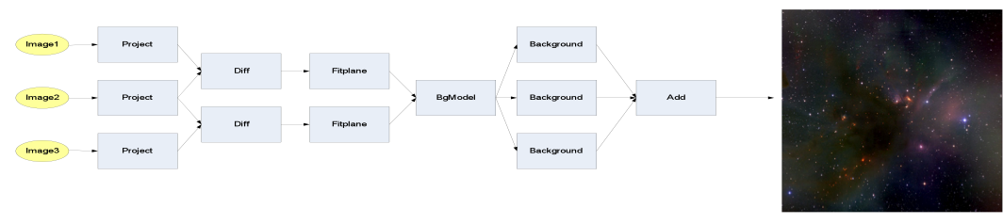

Figure 3: The processing flow in building an image mosaic. See text for a more detailed description. The steps between “Diff” and “Background” are needed to rectify background emission from the sky and the instruments to a common level. The diagram indicates where the flow can be parallelized. Only the computation of the background model and the co-addition of the reprojected, rectified images cannot be parallelized.

An On-Demand Image Mosaic Service
The NASA/IPAC Infrared Science Archive (http://irsa.ipac.caltech.edu) has deployed an on-request image mosaic service. It uses low cost, commodity hardware with portable, Open Source software, and yet is fault-tolerant, scalable, extensible and distributable. Users request a mosaic on a simple web form at http://hachi.ipac.caltech.edu:8080/montage. The service returns mosaics from three wide-area survey data sets: the 2-Micron All-Sky Survey (2MASS), housed at the NASA IPAC Infrared Science Archive (IRSA), the Sloan Digital Sky Survey (SDSS), housed at FermiLab, and the Digital Sky Survey (DSS), housed at the Space Telescope Science Institute (STScI). The first release of the service restricts the size of the mosaics to 1 degree on a side in the native projections of the three datasets. Users may submit any number of jobs, but only ten may run simultaneously and the mosaics will be kept for only 72 hours after creation. These restrictions will be eased once the operational load on the service is better understood. The return page shows a JPEG of the mosaic, and provides download links for the mosaic and an associated weighting file. Users may monitor the status of all their jobs on a web page that is refreshed every 15 seconds, and may request e-mail notification of the completion of their jobs.

Issues of running workflow applications on the Cloud
Today applications such as Montage are asking: What are Clouds? How I do I run on them? How to I make good use of my funds wisely? Often, domain scientists have heard about Clouds but have no good idea of what they are, how to use them, and how much would Cloud resources cost in the context of an application. In this section we posed three cost-related questions ( a more detailed study is presented in [49]):
- How many resources do I allocate for my computation or my service?
- How do I manage data within a workflow in my Cloud applications?
- How do I manage data storage—where do I store the input and output data?

We picked the Amazon services [50] as the basic model. Amazon provides both compute and storage resources on a pay-per-use basis. In addition it also charges for transferring data into the storage resources and out of it. As of the writing of this chapter, the charging rates were:
- $0.15 per GB-Month for storage resources
- $0.1 per GB for transferring data into its storage system
- $0.16 per GB for transferring data out of its storage system
- $0.1 per CPU-hour for the use of its compute resources.

There is no charge for accessing data stored on its storage systems by tasks running on its compute resources. Even though as shown above, some of the quantities span over hours and months, in our experiments we normalized the costs on a per second basis. Obviously, service providers charge based on hourly or monthly usage, but here we assume cost per second. The cost per second corresponds to the case where there are many analyses conducted over time and thus resources are fully utilized.
In this chapter, we use the following terms: application—the entity that provides a service to the community (the Montage project), user request—a mosaic requested by the user from the application, the Cloud—the computing/storage resource used by the application to deliver the mosaic requested by the user.
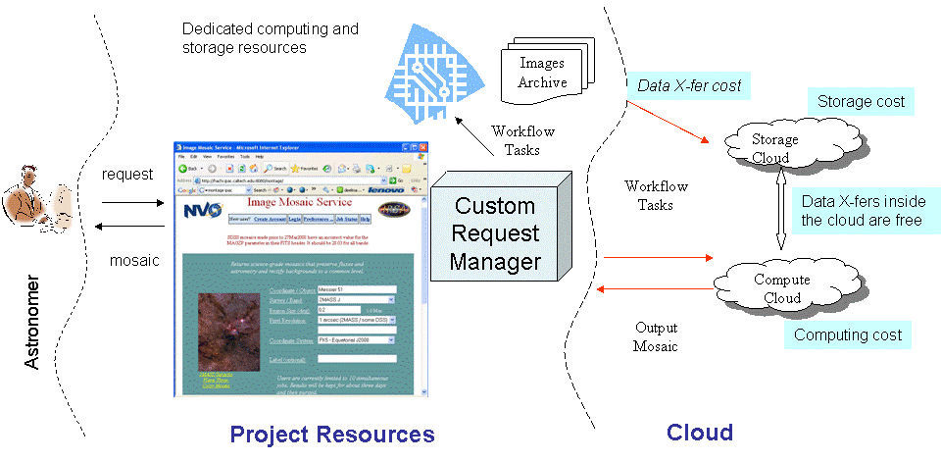
Figure 4. Cloud Computing for a Science Application such as Montage.

Figure 4 illustrates the concept of cloud computing as could be implemented for the use by an application. The user submits a request to the application, in the case of Montage via a portal. Based on the request, the application generates a workflow that has to be executed using either local or cloud computing resources. The request manager may decide which resources to use. A workflow management system, such as Pegasus [15], orchestrates the transfer of input data from image archives to the cloud storage resources using appropriate transfer mechanisms (the Amazon S3 storage resource supports the REST and HTTP transfer protocol [51]). Then, compute resources are acquired and the workflow tasks are executed over them. These tasks can use the cloud storage for storing temporary files. At the end of the workflow, the workflow system transfers the final output from the cloud storage resource to a user-accessible location.
In order to answer the questions raised in the previous section, we performed simulations. No actual provisioning of resources from the Amazon system was done. Simulations allowed us to evaluate the sensitivity of the execution cost to workflow characteristics such as the communication to computation ratio by artificially changing the data set sizes. This would have been difficult to do in a real setting. Additionally, simulations allow us to explore the performance/cost tradeoffs without paying for the actual Amazon resources or incurring the time costs of running the actual computation. The simulations were done using the GridSim toolkit [52]. Certain custom modifications were done to perform accounting of the storage used during the workflow execution.

We used three Montage workflows in our simulations:
- Montage 1 Degree: A Montage workflow for creating a 1 degree square mosaic of the M17 region of the sky. The workflow consists of 203 application tasks.
- Montage 4 Degree: A Montage workflow for creating a 4 degree square mosaic of the M17 region of the sky. The workflow consists of 3,027 application tasks.

These workflows can be created using the mDAG [53] component in the Montage distribution [54]. The workflows created are in XML format. We wrote a program for parsing the workflow description and creating an adjacency list representation of the graph as an input to the simulator. The workflow description also includes the names of all the input and output files used and produced in the workflow. The sizes of these data files and the runtime of the tasks were taken from real runs of the workflow and provided as additional input to the simulator.
We simulated a single compute resource in the system with the number of processors greater than the maximum parallelism of the workflow being simulated. The compute resource had an associated storage system with infinite capacity. The bandwidth between the user and the storage resource was fixed at 10 Mbps. Initially all the input data for the workflow are co-located with the application. At the end of the workflow the resulting mosaic is staged out to the application/user and the simulation completes. The metrics of interest that we determine from the simulation are:
- The workflow execution time.
- The total amount of data transferred from the user to the storage resource.
- The total amount of data transferred from the storage resource to the user.
- The storage used at the resource in terms of GB-hours. This is done by creating a curve that shows the amount of storage used at the resource with the passage of time and then calculating the area under the curve.

We now answers the questions we posed in our study.

How many resources do I allocate for my computation or my service?
Here we examine how best to use the cloud for individual mosaic requests. We calculate how much would a particular computation cost on the cloud, given that the application provisions a certain number of processors and uses them for executing the tasks in the application. We explore the execution costs as a function of the number of resources requested for a given application. The processors are provisioned for as long as it takes for the workflow to complete. We vary the number of processors provisioned from 1 to 128 in a geometric progression. We compare the CPU cost, storage cost, transfer cost, and total cost as the number of processors is varied. In our simulations we do not include the cost of setting up a virtual machine on the cloud or tearing it down, this would be an additional constant cost.

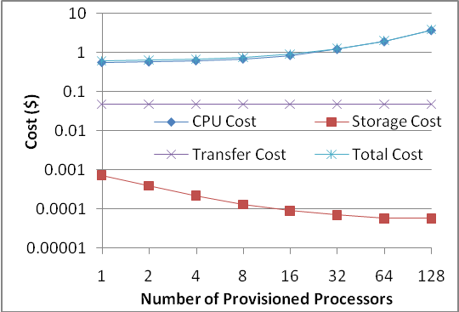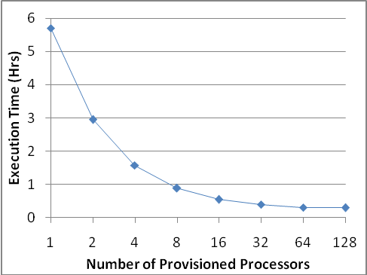
Figure 5: Cost of One Degree Square Montage on the Cloud.
The Montage 1 degree square workflow consists of 203 tasks and in this study the workflow is not optimized for performance. Figure 5 shows the execution costs for this workflow. The most dominant factor in the total cost is the CPU cost. The data transfer costs are independent of the number of processors provisioned. The figure shows that the storage costs are negligible as compared to the other costs. The Y-axis is drawn in logarithmic scale to make the storage costs discernable. As the number of processors is increased, the storage costs decline but the CPU costs increase. The storage cost declines because as we increase the number of processors, we need them for shorter duration since we can get more work done in parallel. Thus we also need storage for shorter duration and hence the storage cost declines. However, the increase in the CPU cost far outweighs any decrease in the storage costs and as a result the total costs also increase with the increase in the number of provisioned processors. The total costs shown in the graphs are aggregated costs for all the resources used.
Based on Figure 5, it would seem that provisioning the least amount of processors is the best choice, at least from the point of view of monetary costs (60 cents for the 1 processor computation versus almost 4$ with 128 processors). However, the drawback in this case is the increased execution time of the workflow. Figure 5 (right) shows the execution time of the Montage 1 Degree square workflow with increasing number of processors. As the figure shows, when only one processor is provisioned leading to the least total cost, it also leads to the longest execution time of 5.5 hours. The runtime on 128 processors is only 18 minutes. Thus a user who is also concerned about the execution time, faces a trade-off between minimizing the execution cost and minimizing the execution time.

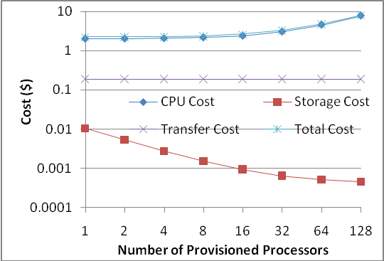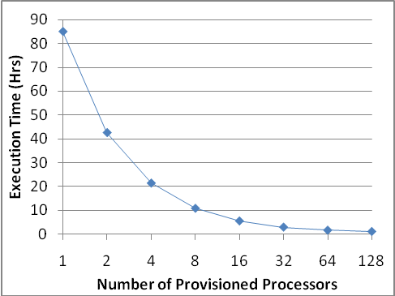
Figure 6: Costs and Runtime for the 4 Degree Square Montage Workflow.

Figure 6 shows similar results for the Montage 4 degree workflow as for the 1 degree Montage workflow. The Montage 4 degree square workflow consists of 3,027 application tasks in total. In this case running on 1 processor costs $9 with a runtime of 85 hours; with 128 processors, the runtime decreases to 1 hour with a cost of almost $14. Although the monetary costs do not seem high, if one would like to request many mosaics to be done, as would be in the case of providing a service to the community, these costs can be significant. For example, providing 500 4-degree square mosaics to astronomers would cost $4,500 using 1 processor versus $7,000 using 128 processors. However, the turnaround of 85 hours may be too much to take by a user. Luckily, one does not need to consider only the extreme cases. If the application provisions 16 processors for the requests, the turnaround time for each will be approximately 5.5 hours with a cost of $9.25, and thus a total cost of 500 mosaics would be $4,625, not much more than in the 1 processor case, while giving a relatively reasonable turnaround time.

How do I manage data within a workflow in my Cloud applications?
For this question, we examine three different ways of managing data within a workflow. We present three different implementation models that correspond to different execution plans for using the Cloud storage resources. In order to explain these computational models we use the example workflow shown in Figure 7. There are three tasks in the workflow numbered from 0 to 2. Each task takes one input file and produces one output file.
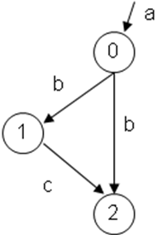

Figure 7. An Example Workflow.

We explore three different data management models:
- Remote I/O (on-demand): For each task we stage the input data to the resource, execute the task, stage out the output data from the resource and then delete the input and output data from the resource. This is the model to be used when the computational resources used by the tasks have no shared storage. For example, the tasks are running on hosts in a cluster that have only a local file system and no network file system. This is also equivalent to the case where the tasks are doing remote I/O instead of accessing data locally. Figure 8 (a) shows how the workflow from Figure 7 looks like after the data management tasks for the Remote I/O are added by the workflow management system.

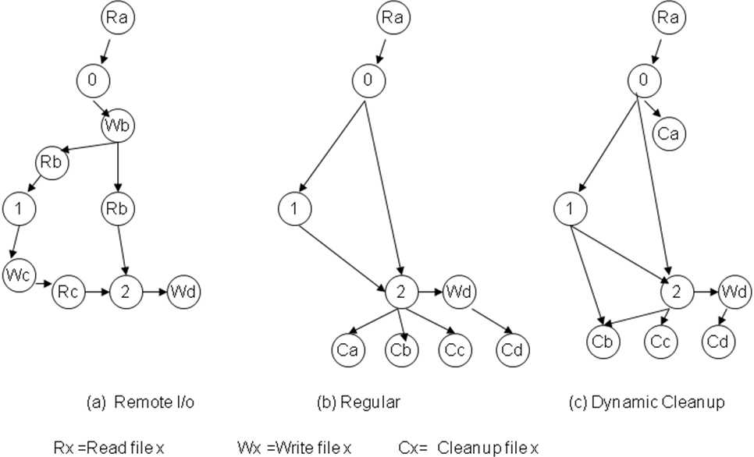

Figure 8: Different modes of data management.

- Regular: When the compute resources used by the tasks in the workflow have access to shared storage, it can be used to store the intermediate files produced in the workflow. For example, once task 0 (Figure 8b) has finished execution and produced the file b, we allow the file b to remain on the storage system to be used as input later by tasks 1 and 2. In fact, the workflow manager does not delete any files used in the workflow until all the tasks in the workflow have finished execution. After that file d which is the net output of the workflow is staged out to the application/user and all the files a – c are deleted from the storage resource. As mentioned earlier this execution mode assumes that there is shared storage that can be accessed from the compute resources used by the tasks in the workflow. This is true in the case of the Amazon system where the data stored in the S3 storage resources can be accessed from any of the EC2 compute resources.
- Dynamic cleanup: In the regular mode, there might be files occupying storage resources even when they have outlived their usefulness. For example file a is no longer required after the completion of task 0 but it is kept around until all the tasks in the workflow have finished execution and the output data is staged out. In the dynamic cleanup mode, we delete files from the storage resource when they are no longer required. This is done by Pegasus by performing an analysis of data use at the workflow level [55]. Thus file a would be deleted after task 0 has completed, however file b would be deleted only when task 2 has completed (Figure 8c). Thus the dynamic cleanup mode reduces the storage used during the workflow and thus saves money. Previously, we have quantified the improvement in the workflow data footprint when dynamic cleanup is used for data-intensive applications similar to Montage [56]. We found that dynamic cleanup can reduce the amount of storage needed by a workflow by almost 50%.

Here we examine the issue of the cost of user requests for scientific products when the application provisions a large number of resources from the Cloud and then allows the request to use as many resources as it needs. The application is in this scenario responsible for scheduling the user requests onto the provisioned resources (similarly to the Personal Cluster approach). In this case, since the processor time is used only as much as needed, we would expect that the data transfer and data storage costs may play a more significant role in the overall request cost. As a result, we examine the tradeoffs between using three different data management solutions: 1) remote I/O, where tasks access data as needed, 2) regular, where the data are brought in at the beginning of the computation and they and all the results are kept for the duration of the workflow, and 3) cleanup, where data no longer needed are deleted as the workflow progresses. In the following experiments we want to determine the relationship between the data transfer cost and the data storage cost and compare it to the overall execution cost.
Figure 9 (left) shows the amount of storage used by the workflow in the three modes in space-time units for the 1 degree square Montage Workflow. The least storage used is in the remote I/O mode since the files are present on the resource only during the execution of the current task. The most storage is used in the regular mode since all the input data transferred and the output data generated during the execution of the workflow is kept on the storage until the last task in the workflow finishes execution. Cleanup reduces the amount of storage used in the regular mode by deleting files when they are no longer required by later tasks in the workflow.
Figure 9 (middle) shows the amount of data transfer involved in the three execution modes. Clearly the most data transfer happens in the remote I/O mode since we transfer all input files and transfer all output files for each task in the workflow. This means that if the same file is being used by more than on job in the workflow in the remote I/O mode the file may be transferred in multiple times whereas in the case of regular and cleanup modes, the file would be transferred only once. The amount of data transfer in the Regular and the Cleanup mode are the same since dynamically removing data at the execution site does not affect the data transfers. We have categorized the data transfers into data transferred to the resource and data transferred out of the resource since Amazon has different charging rates for each as mentioned previously. As the figure shows, the amount of data transferred out of the resource is the same in the Regular and Cleanup modes. The data transferred out is the data of interest to the user (the final mosaic in case of Montage) and it is staged out to the user location. In the Remote I/O mode intermediate data products that are needed for subsequent computations but are not of interest to the user also need to be stage-out to the user-location for future access. As a result, in that mode the amount of data being transferred out is larger than in the other two execution strategies.
Figure 9 (right) shows the costs (in monetary units) associated with the execution of the workflow in the three modes and the total cost in each mode. The storage costs are negligible as compared to the data transfer costs and hence are not visible in the figure. The Remote I/O mode has the highest total cost due to its higher data transfer costs. Finally, the Cleanup mode has the least total cost among the three. It is important to note that these results are based on the charging rates currently used by Amazon. If the storage charges were higher and transfer costs were lower, it is possible that the Remote I/O mode would have resulted in the least total cost of the three.
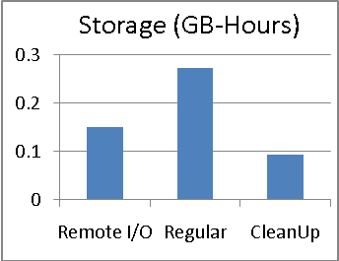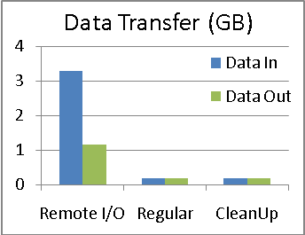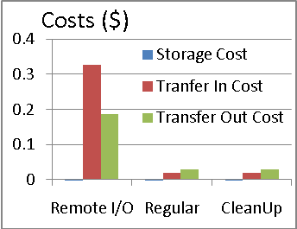
Figure 9: Data Management Costs for the 1 degree square Montage.
Figure 10 shows the metrics for the Montage 4 degrees square workflow. The cost distributions are similar to the smaller workflow and differs only in magnitude as can be seen from the figures.

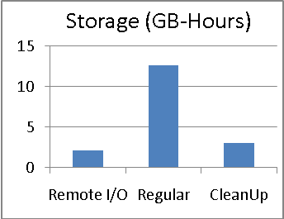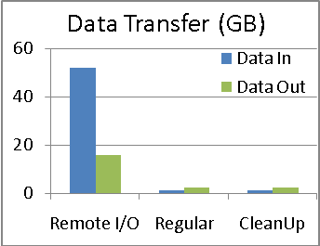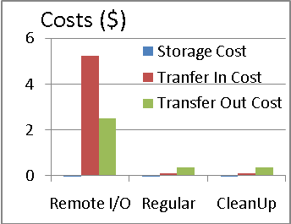
Figure 10: Data Management Costs for the 4 degree square Montage.

We also wanted to quantify the effect of the different workflow execution modes on the overall workflow cost. Figure 11 shows these total costs. We can see that there is very little difference in cost between the Regular and Cleanup mode, thus if space is not an issue, cleaning up the data alongside the workflow execution is not necessary. We also notice that the cost of Remote I/O is much greater because of the additional cost of data transfer.

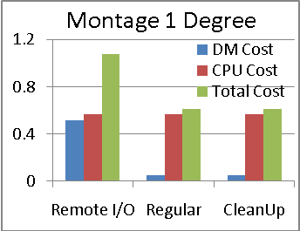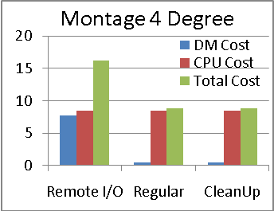
Figure 11: Overall Workflow Cost for Different Data Management Strategies.

How do I manage data storage—where do I store the input and output data?
In the study above we assumed that the main data archive resided outside of the Cloud and that when a mosaic was being computed, only that data was being transferred to the Cloud. We also wanted to ask the question whether it would make sense to store the data archive itself on the Cloud. The 2Mass archive that is used for the mosaics takes up approximately 12TB of storage which on Amazon would cost $1,800 per month. Calculating a 1 degree square mosaic and delivering it to the user costs $2.22 when the archive is outside of the Cloud. When the input data is available on S3, the cost of the mosaic goes down to $2.12. Therefore to overcome the storage costs, users would need to request at least $1,800/($2.22-$2.12) = 18,000 mosaics per month which is high for today’s needs. Additionally, the $1,800 cost does not include the initial cost of transferring data into the Cloud which would be an extra $1,200.
Is $1,800 cost of storage reasonable as compared to the amount spent by the Montage project? If we add up the cost of storing the archive data on S3 over three years, it will cost approximately $65,000. This cost does not include access to the data from outside the Cloud. Currently, the Montage project is spending approximately $15,000 over three years for 12TB of storage. This includes some labor costs but does not include facility costs such as space, power, etc. Still it would seem that the cost of storage of data on the Cloud is quite expensive.

Conclusions
In this chapter we took a first look at issues related to running scientific applications on Cloud. In particular we focused on the cost of running the Montage application on Amazon Cloud. We used simulations to evaluate these costs. We have seen that there exists a classic tradeoff between the runtime of the computation and its associated cost and that one needs to find a point at which the costs are manageable while delivering performance that can meet the users’ demands. We also demonstrated that storage on the Cloud can be costly. Although this cost is minimal when compared to the CPU cost of individual workflows, over time the storage cost can be significant.
Clouds are still in their infancy--there are only a few commercial [57-59] and academic providers [21, 22]. As the field matures, we expect to see a more diverse selection of fees and quality of service guarantees for the different resources and services provided by Clouds. It is possible that some providers will have a cheaper rate for compute resources while others will have a cheaper rate for storage and provide a range of quality of service guarantees. As a result, applications will have more options to consider and more execution and provisioning plans to develop to address their computational needs.
Many other aspects of the problem still need to be addressed. These include the startup cost of the application on the cloud, which is composed of launching and configuring a virtual machine and its teardown, as well as the often one-time cost of building a virtual image suitable for deployment on the cloud. The complexity of such an image depends on the complexity of the application. We also did not explore other cloud issues such as security and data privacy. The reliability and availability of the storage and compute resources are also an important concern.
The question exists whether scientific applications will move into the Cloud. Clearly, there is interest in the new computational platform, the promise of on-demand, pay-as-you-go resources is very attractive. However, much needs to be done to make Clouds accessible to a scientist. Tools need to be developed to manage the Cloud resources and to configure them in a way suitable for a scientific application. Tools need to be developed to help build and deploy virtual images, or libraries of standard images need to be built and made easily available. Users need help with figuring out the right number of resources to ask for and to be able to estimate their associated costs. Costs also should be evaluated not only on a individual application bases but on the scale of an entire project.
At the beginning of this chapter we described three cornerstones of the scientific method: reproducibility, provenance, and sharing. Now we try to reflect on whether these desirable characteristics are more easily reached with Clouds and their associated virtualization technologies. It is possible that reproducibility will be easier to achieve through the use of virtual environments. If we package the entire environment, then reusing this setup would make it easier to reproduce the results (provided that the virtual machines reliably can produce the same execution). The issue of provenance is not made any easier with the use of Clouds. Tools are still needed to capture and analyze what happened. It is possible that virtualization will actually make it harder to trace the exact execution environment and its configuration in relation to the host system. Finally, in terms of sharing entire computations, it may be easier to do it with virtualization as all the software, input data, and workflows can be packaged up in one image.
Acknowledgments
This work was funded in part by the National Science Foundation under Cooperative Agreement OCI-0438712 and grant # CCF-0725332. Montage was funded by the National Aeronautics and Space Administration's Earth Science Technology Office, Computation Technologies Project, under Cooperative Agreement Number NCC5-626 between NASA and the California Institute of Technology. Montage is maintained by the NASA/IPAC Infrared Science Archive.
References

