Baseline Performance:
yourSky Mosaicking Code

Code Description:
The yourSky mosaicking code can be used to construct astronomical image mosaics with user-specified center location, size, resolution, coordinate system (Galactic, Ecliptic, J2000 or B1950 Equatorial), projection (any of the standard World Coordinate System projections), image format (FITS or raw data directly supported; JPEG, PGM, PNG, and TIFF support via an external image conversion from raw data), and data type (double and single precision floating point, 32 and 16 bit signed integer, and 8-bit unsigned integer support for FITS; additional 32 and 16 bit unsigned integer and 8-bit signed integer support for raw data). The mosaic size can be determined automatically from the input images, or it can be constrained by user-specified parameters, including distance in degrees from the mosaic center, width, or height in pixels. An optional background-matching mode can be enabled which subtracts off the 25th percentile gray level from each input image in an effort to equalize the zero-levels among the input images.
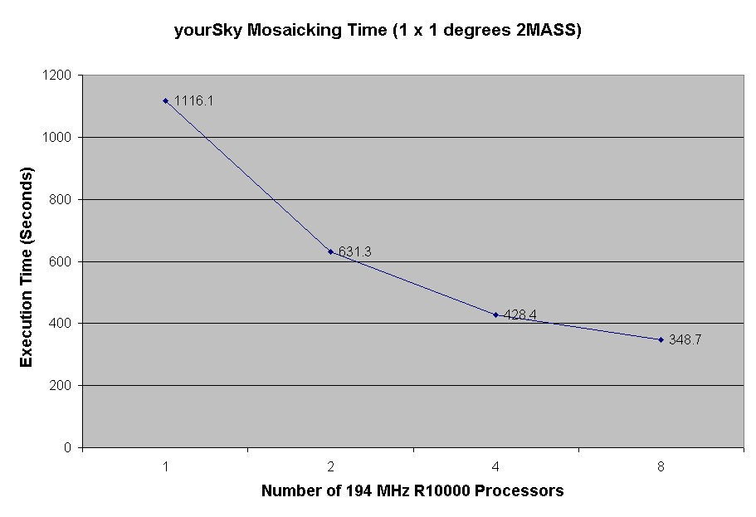
Figure 1. Baseline performance of yourSky mosaicking code on an 8 processor SGI Poweronyx.

Baseline Test
This baseline performance of this code was determined on an SGI Poweronyx with eight 194 MHz R10000 processors. The mosaic constructed for the baseline was a 1 x 1 degree 2MASS H band mosaic of the galactic center in galactic coordinates, TAN projection, full 1 arc second resolution, 16-bit signed integer FITS format, with background matching enabled. A plot of execution time versus number of processors is shown in Figure 1. Construction of the baseline mosaic required 52 input images of total size ~107MB and resulted in a ~26MB mosaic of size 3601 x 3601 pixels.

Discussion
The scaling performance of this code was adversely affected by the following factors: (1) the baseline performance was done on a shared machine that is quite heavily used, and the background load on the machine was around 4 at the time the tests were done, as determined using the Unix top application; (2) I/O performance was quite poor since it was done over slow, shared disks that typically see heavy traffic and have become fragmented over time. In addition, the absolute performance was adversely affected by the outdated processors that were used. If the baseline test is repeated on a better class machine, significantly better scaling is expected up to at least 64 processors (the largest partition on which we have run this code on an SGI Origin 2000 with superior processors and I/O performance than the Poweronyx).

Download
Everything required to repeat the baseline testing of the yourSky mosaicking code is available to download via anonymous ftp from jabba.jpl.nasa.gov. A gzipped tarball is available containing:
- The yourSky mosaicking code executable, called sky_mosaic.
- A script to run sky_mosaic on user-specified number of processors, called run_it.
- A set of 52 2MASS Atlas images required to construct the sample 1x1 degree center of the galaxy H-band mosaic.
- A sample FITS file that should be by run_it, called samp.fits.
- Sample text debug output files produced by sky_mosaic on 1, 2, 4, and 8 processors, called samp1.txt, samp2.txt, samp4.txt, and samp8.txt.
Instructions for retrieving the baseline test material, unpacking it, and conducting the test are as follows:
- ftp jabba.jpl.nasa.gov; login as anonymous, enter your email as password.
- bin (switch to binary mode)
- cd /pub/jjacob
- get yoursky_baseline_test.tgz
- quit
- gtar xvfz yoursky_baseline_test.tgz
- cd yoursky_baseline_test
- ./run_it N where N = number of processors to use, e.g. ./run_it 4 to run on 4 processors.

